Immigrant Justice Partnership
ICE Emergency Response
& Documentation

The Michigan Immigrant Rights Center (MIRC) and the ACLU of Michigan have partnered through our Immigrant Justice Partnership to train pro-bono attorneys to:
- Document ICE & CBP raids and arrests allowing MIRC and the ACLU to identify priority or impact cases and track enforcement patterns
Email
crisis@michiganimmigrant.org or call MIRC’s intake line
734-239-6863.
Please provide:
- Any details you have about the incident (where and when)
- Detained person’s full name (and DOB, Country of Origin, and A number – if possible)
- Where the person is detained
- Primary Family Contact (Name + Phone Number)

- Provide basic advice to detained individuals and their families regarding their rights in detention
- Provide referral information to immigration attorneys and legal services
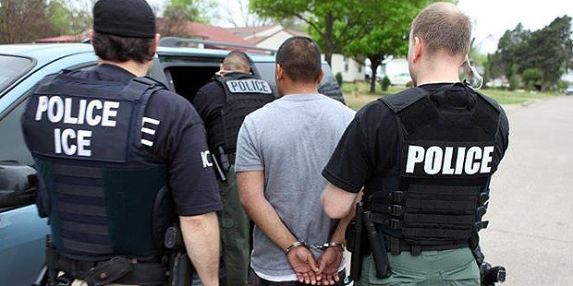
All information collected will remain confidential. Due to limited capacity and training, these volunteers are not taking cases or providing full representation. We do however, hope this will be a valuable resource to families and provide much needed data on ICE practices.
